Digital Stop Watch

M1 M0 S1 S0

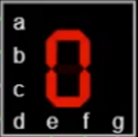

Team members:

* Ahmed Bassam Abdelaal 202101074
* Mohammed Sayed 2021004384
* Khaled Ashraf Mousa 202100751

Table of Contents

1. Design Goals
2. Brainstorming and chosen Approaches

2.1 Stop watch with Synchronous counter

2.2 Stop watch with asynchronous counter

2.3 Stop watch with registers and adders

2.4 Rating design approaches

1. Chosen Design Logic and Implementation

3.1 Timer (4 Counters)

3.1.1 BCD Up & Down Counter

3.1.2 0to6 Up & Down Counter

1. Used Elements
2. Faced Problems while designing & their solutions

1- Design Goals

We have been asked to design a stopwatch and count down in a single circuit.

The features are:

* Count up to a specific second then stop
* Count down to a specific second then stop
* You can stop counting whenever you want
* While counting up you can add 2 minutes
* While counting down you can subtract 2 minutes
* Timing rate can be 0.5x or 2x
* The output should be visible on a seven segment display

Based on these features that we want to do, we thought that for this project we need some blocks to do these features:

* Block for counting
* Block for specifying counting mode up/down
* Block for addition and subtraction
* Block for changing the speed of Counting
* Block for stopping the counting
* Block for displaying the output

So as a start we want to make this:

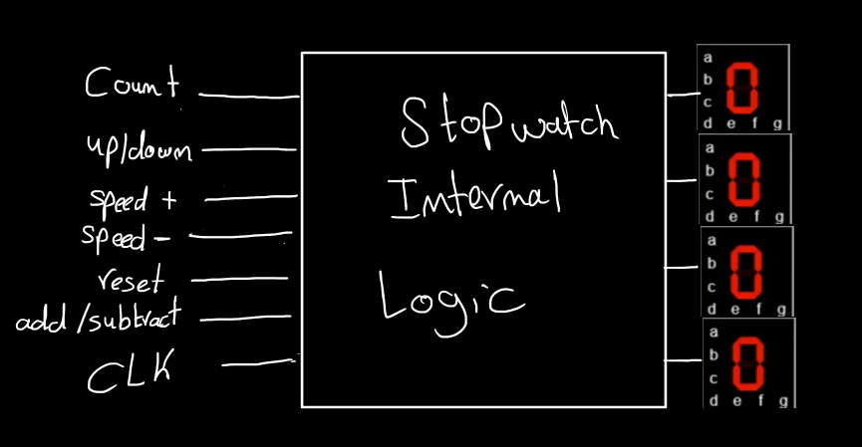

In the next section we gathered the different methods thought of to implement such a thing

2- Brainstorming &

chosen Approaches

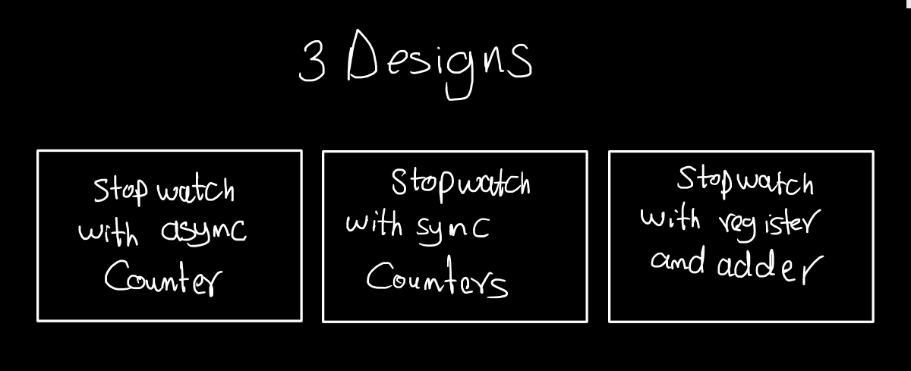

2.1 Stopwatch with synchronous Counter

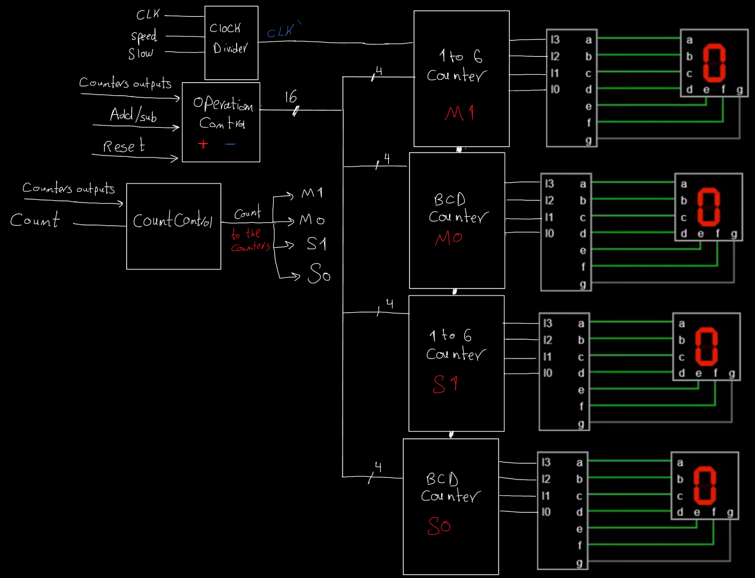

You can see that:

* We used both BCD synchronous counters and 0to5 synchronous counters
* Also the output of the counters is a feedback to the operation control and count control blocks.
* Count control is the block that stops the counter on max or min or when user asks to stop.
* Operation Control is used to add or subtract 2 minutes but if the addition or subtraction can’t exceed the maximum or minimum values.

2.2 Stopwatch with asynchronous Counter

This design is the same as the previous in terms of blocks in the design but the counter we thought of was asynchronous.

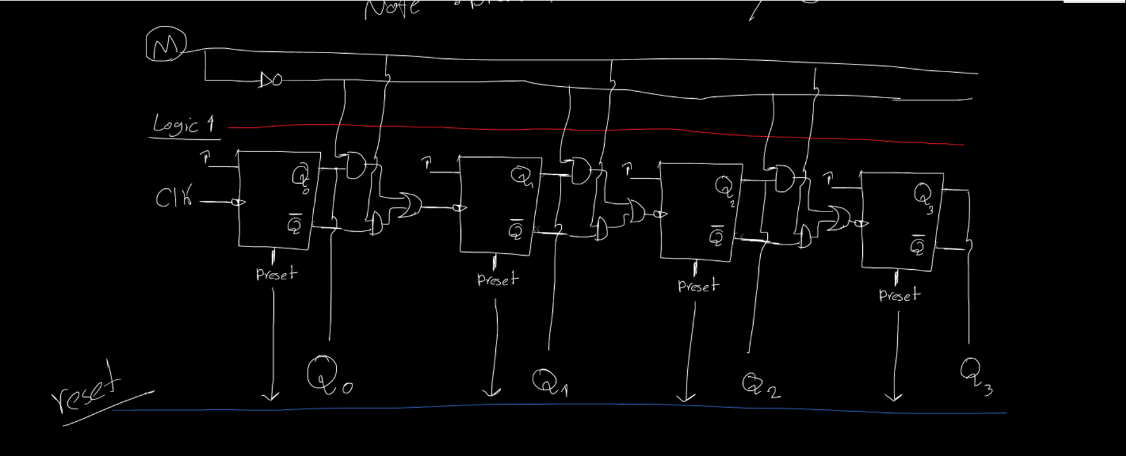We tried to draw it and we have done its simulation on Flastad website

Then all counters will be connected to each other asynchronously.

2.3 Stopwatch with Registers and Adders

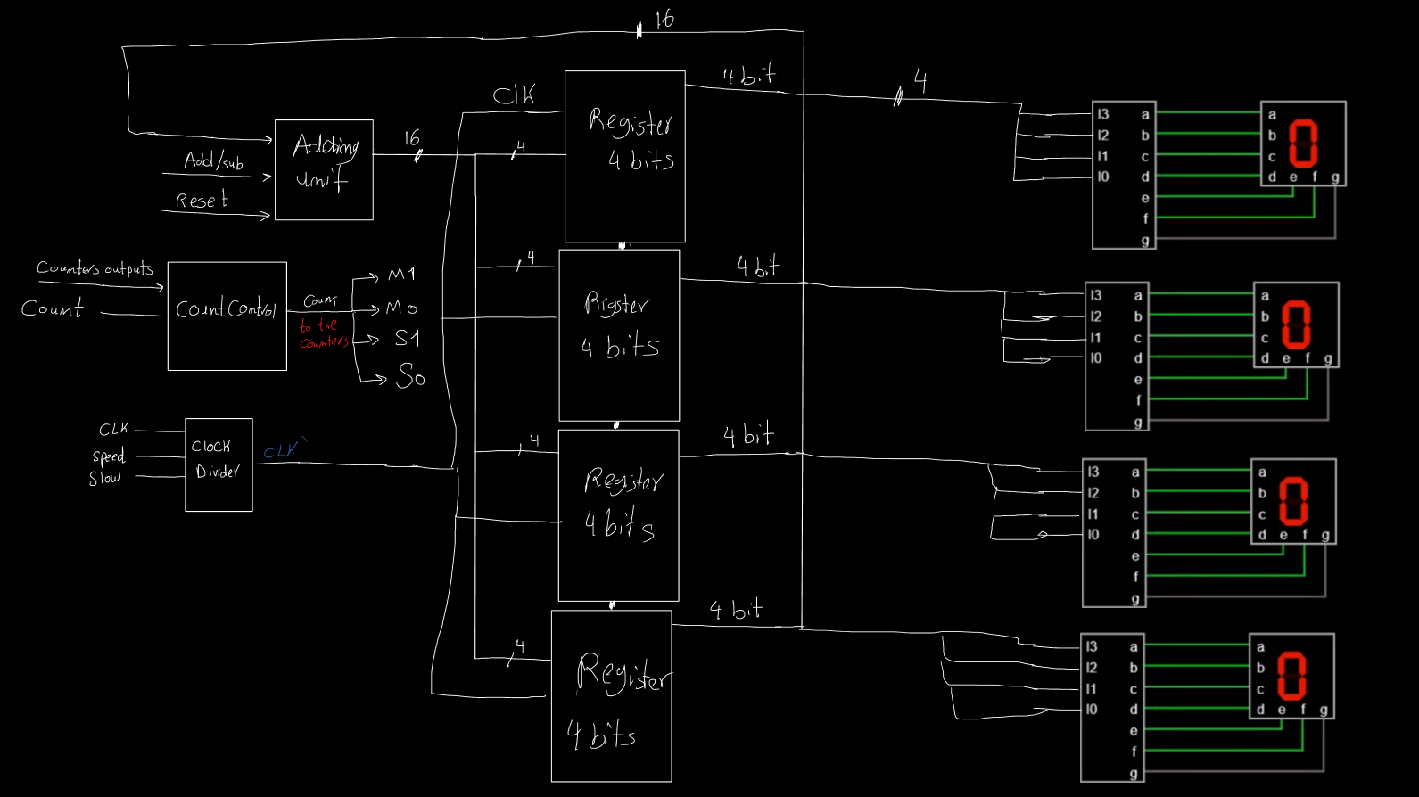

In this design we thought of storing the value in a register and then display it and also take the output as a feedback to an adding unit that has some adders and subtractors to count up or down based on the inputs used.

* The clock divider will do the same job as the registers require clock
* The count control here will be little bit tricky as I have to stop the clock to stop the register from loading

Now the next sub section will discuss the design chosen and reasons of that choice.

2.4 Rating Design Approaches

let’s first see what are the disadvantages of each design

asynchronous counter design:

The main problem is that the asynchronous counter can have unexpected behavior and also it will be complex to control each value because there will be a different logic for each bit.

Register and adder design:

The main problem of this design is the adding unit it will be complicated and why making it add 1 every clock cycle when I have a counter that does the same thing by simple gates between the JK flip flops

Also if we used this logic there will be higher delay in adding ones to the register because the signal goes through more components

asynchronous counter design:

we can conclude that using this method is the best in our opinion because the logic of each bit will be the same unlike the asynchronous counter. Also the asynchronous counter will act as a register to load the new values that the user enters through adding two minutes.

3- Chosen Design

Logic & Implementation

as previously seen in the block design of the synchronous counter we need to make the logic and code of the following components:

1. Timer (4 counters)
   1. BCD Up & Down Counter
   2. 0To6 Counter
2. Clock Divider
3. Operation Control Unit
   1. BCD adder
   2. BCD subtractor
   3. Comparator
   4. Checker
4. Count Control Unit
5. Output Display Unit

3.1 Timer

In this Logic we need 4 counters (two BCD for seconds and minutes first digit) (two 0 to 5 counters for second digit) As the maximum in natural stopwatches is 59:59

We are aware that the maximum count for this project is different but this will be implemented in the Count Control Unit.

As Seen the first counter has the clock given and when it reaches its maximum value it motivates the next counter to count.

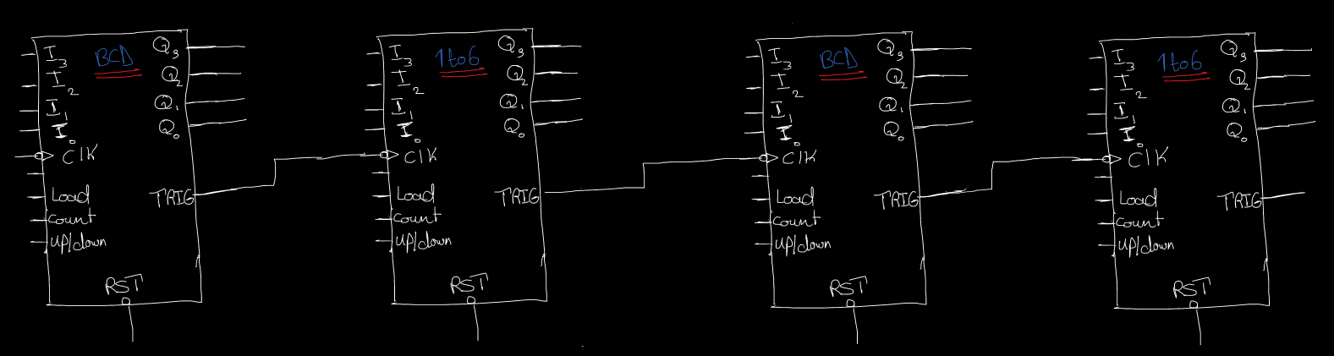

We need in each counter the following inputs:

- I3, I2, I1, I0 is the inputs through which we can change the value when the user adds or subtracts.

- CLK for the general clock of the flip flops inside the counter

- Load input to stop counting and displays the inputs I3, I2, I1, I0

- Count input to start and stop counting

- Up/Down input to specify the mode of counting up or down

In the next section and the following one we will discuss how we build BCD counter with aforementioned inputs, features.

3.1.1 BCD Up & Down Counter

Here is the function table for the counter

|  |  |  |  |  |  |
| --- | --- | --- | --- | --- | --- |
| Load | Count | Up/Down | Function | J | K |
| 1 | x | x | Load Inputs | Input | Input’ |
| 0 | 0 | X | Pause | 0 | 0 |
| 0 | 1 | 1 | Count Up | Eqn Up | Eqn Up |
| 0 | 1 | 0 | Count Down | Eqn Down | Eqn Down |

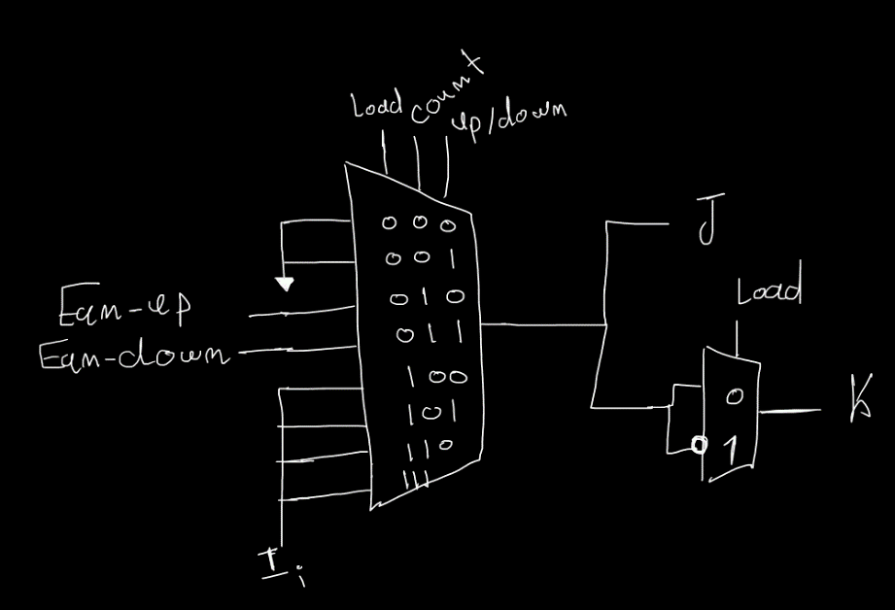To implement this function table, we will put MUX8 between every JK flip fop to determine the inputs.

As you can see we also used mux 2

And an inverter to make the k input is the I’ while loading only.

The next step is that we want to make the counter reset its value when it reaches to 1001 = 9 when counting up.

So we can take and gate from [Pending Mohammed Sayed]

We also need to make the counter get back to 9 when counting down and reaching zero because if we didn’t make logic for it, the counting will continue to 1111.

So we can take and gate from [pending Mohammed Sayed]

Finally, we need a trigger to activate the next counter and make it count

We will make this trigger go to the clock of the following counter and this trigger is or gate from the [pending Mohammed Sayed]

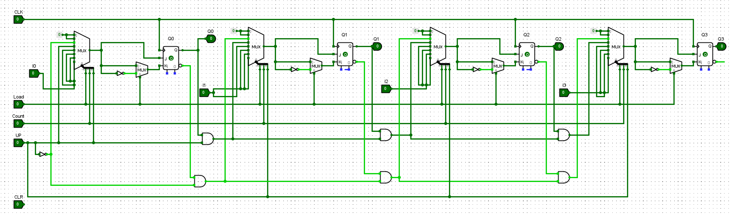BCD up and down Counter Schematic

Components:

. JK Flip Flop with asynchronous Reset and Preset

. MUX 8

. MUX 2

. AND Gate

. OR Gate

. Not Gate

3.1.2 0 to 5 Up & Down Counter

This component is similar to the BCD up and down counter but the reset logic and the trigger logic will be different because you want to reset at 5 which is 1010 in counting up mode and also return to the five again when zero is reached.

Function table is the same as the BCD up and down counter

|  |  |  |  |  |  |
| --- | --- | --- | --- | --- | --- |
| Load | Count | Up/Down | Function | J | K |
| 1 | x | x | Load Inputs | Input | Input’ |
| 0 | 0 | X | Pause | 0 | 0 |
| 0 | 1 | 1 | Count Up | Eqn Up | Eqn Up |
| 0 | 1 | 0 | Count Down | Eqn Down | Eqn Down |

The same combination of MUX 8 and MUX2 is used to determine the input to the JK flip flops.

For resetting and the Trigger Logic:

Pending Mohammed Sayed

0 to 5 up and down Counter Schematic

Components:

. JK Flip Flop with asynchronous Reset and Preset

. MUX 8

. MUX 2

. AND Gate

. OR Gate

. Not Gate